**I Love Soup!**

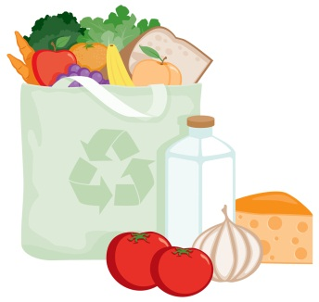

We bought meat and yummy veggies at the grocery store

C:\Users\Darin\AppData\Local\Microsoft\Windows\Temporary Internet Files\Content.IE5\XR66HM6I\MC900296144[1].wmf

I watch mom chop them up and make delicious soup



After a couple hours, the soup is ready

C:\Users\Darin\AppData\Local\Microsoft\Windows\Temporary Internet Files\Content.IE5\DJ8OGYUS\MC900001288[1].wmf

Playing all morning has made me hungry!

C:\Users\Darin\AppData\Local\Microsoft\Windows\Temporary Internet Files\Content.IE5\Q3NGIGSR\MC900054775[1].wmf

I go to the table and sit in my chair

C:\Users\Darin\AppData\Local\Microsoft\Windows\Temporary Internet Files\Content.IE5\XR66HM6I\MC900112818[1].wmf

Mom gives me soup in a bowl

C:\Users\Darin\AppData\Local\Microsoft\Windows\Temporary Internet Files\Content.IE5\XR66HM6I\MC900445222[1].wmf

I tell her thank you!

C:\Users\Darin\AppData\Local\Microsoft\Windows\Temporary Internet Files\Content.IE5\A43BHLYX\MC900001323[1].wmf

We all eat our meal together

C:\Users\Darin\AppData\Local\Microsoft\Windows\Temporary Internet Files\Content.IE5\DJ8OGYUS\MC900098021[1].wmf

I eat with my spoon



I love yummy soup!

C:\Users\Darin\AppData\Local\Microsoft\Windows\Temporary Internet Files\Content.IE5\XR66HM6I\MC900383592[1].wmf

Eating soup makes my tummy feel nice and warm

C:\Users\Darin\AppData\Local\Microsoft\Windows\Temporary Internet Files\Content.IE5\Q3NGIGSR\MC900250488[1].wmf

When I’m all done, I bring my bowl and spoon to the sink

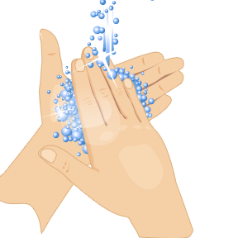

And wash my hands and face



And now I have a full tummy and feel good so I will grow big and strong and have lots of energy to do fun things!